Breaker Diagram
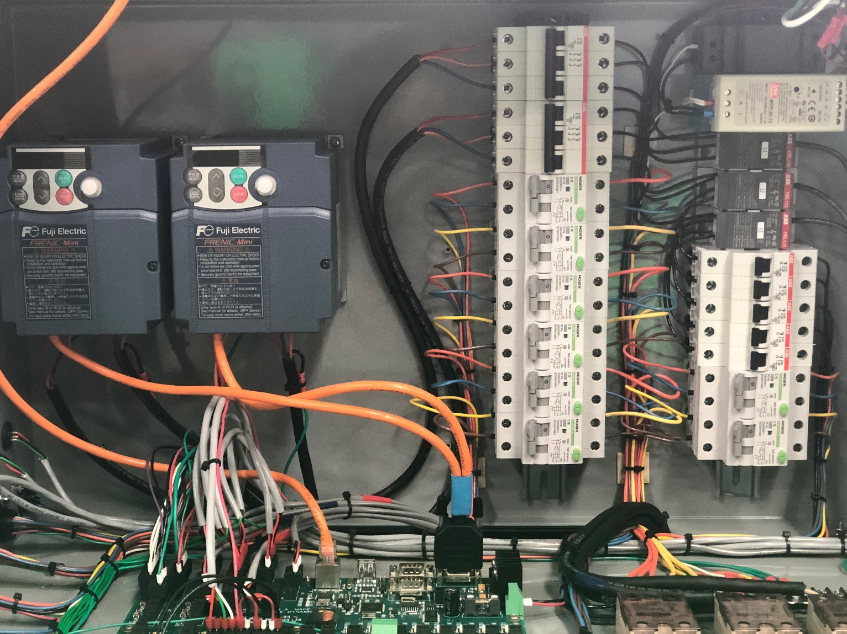
11.
13.
19.
20.
18.
1.
2.
17.
16.
Iso (A) Motor Drive
Resin (B) Motor Drive
10.
12.
14.
15.
9.
3
5.
4.
6.
7.
8.10
Figure 1

1. | - Iso (A) Drive | 8. | - Section 4 Resin (B) Hose Heat | 15. | Resin Closed Cell Heater (Heater C)
2. | - Resin (B) Drive | 9. | - Section 3 Iso (A) Hose Heat | 16. | - 5V Power Supply
3. | - Section 1 Iso (A) Hose Heat | 10. | Section 3 Resin (B) Hose Heat | 17. | - 12V Power Supply
4. | - Section 1 Resin (B) Hose Heat | 11. | - Iso (A) Master Hose Heat | 18. | - L1 Power Distribution Blocks
5. | - Section 2 Iso (A) Hose Heat | 12. | - Resin (B) Master Hose Heat | 19. | - L2 Power Distribution Blocks
6. | - Section 2 Resin (B) Hose Heat | 13. | Iso (A) Heater (Heater A) | 20. | - L3 Power Distribution Blocks
7. | - Section 4 Iso (A) Hose Heat | 14. | Resin Open Cell Heater (Heater B)

Notes:
Breakers 9 and 10 are only present for 250 & 300 ft Hoses
Breaker 12 also controls power to transfer pumps with single proportioner and single tanks. If dual proportioner – Hose Heat Only
*Remember: Red is Hot, Green is Not on GFCI (3-10)
Bringing Up a New Proportioner
When bringing up a new proportioner, the general process to follow is as follows:
- Initial Configuration
- Sensor Check
- Transfer Pump Check
- Fill Heaters
- Fill Lines
- Hose Diagnostics
- Test Spray

Initial Configuration
First step is to setup the software for the Rig Configuration. Press the Akurate Logo in the top left corner of the Main Screen (Figure 2), this will take you to raw value screen (Figure 3).
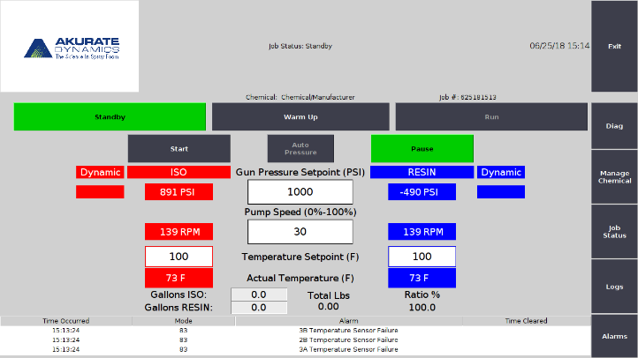
Figure 2
From the raw value screen you can activate or deactivate Section 2 and 3, if installed. If both sections are present in the hose, make sure the buttons read “Active” (Press the button to toggle inactive/active). If a Section is not present in the hose, make sure that section reads “Inactive”. Next, from this screen, press the button “Control Board Version” in the bottom right corner.

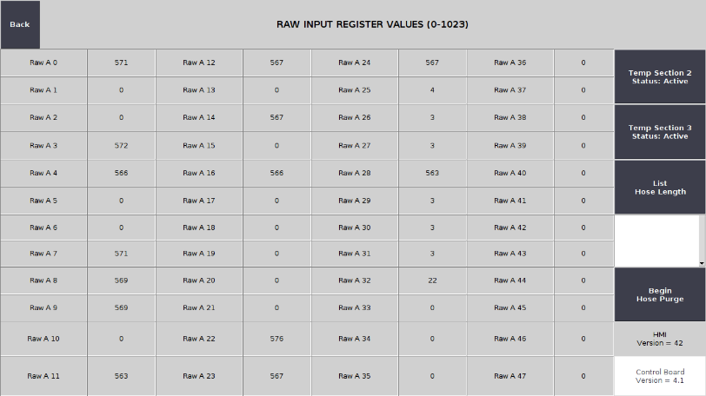
Figure 3
On the left side of this screen are several questions that pertain to the equipment and proportioner components. Select the option for each question in the list, seen in Figure 4. If you don’t have tank temp and level sensors, make sure “Tank Alarms” are set to off.
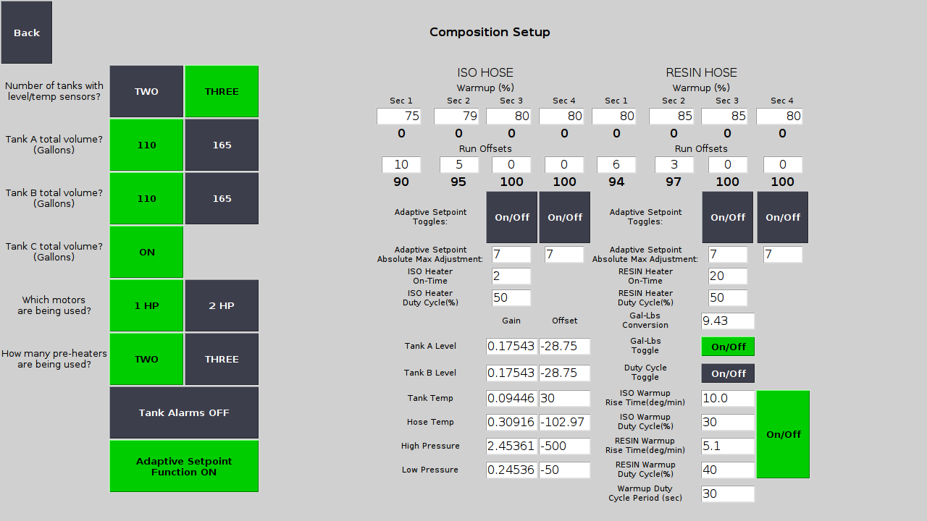
Figure 4
Once you have completed the configuration, press the “Back” button on this screen and the Raw Value Screen and that will take you back to the Main Screen. Then move on to sensor check.

Sensor Check
The first thing to look for with a new proportioner is that the system is receiving logical values from all sensors. Any largely negative, extremely high, or illogical number (60˚F when it’s 90˚F outside) is a likely indication that there is an issue with the sensor or there is a bad connection somewhere along the way. Specific examples of known error values are: “-102” which is an indication that the sensor is not plugged in or there is not a sensor there at all and “-495” which indicates a sensor failure. All sensor data can be found between the Diagnostics (Figure 6) and Manage Chemical (Figure 8) screens.
Diagnostics Screen:
- Heater Pressures
- Heater Temperature
- Section Hose Heat

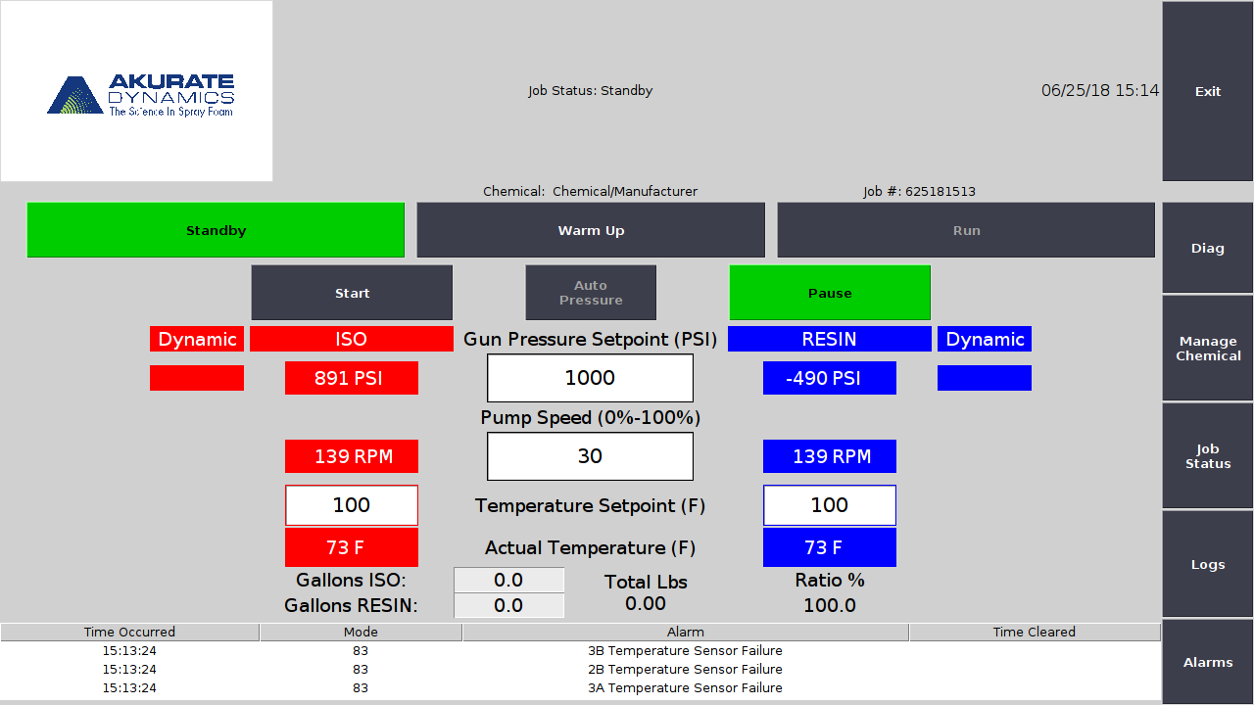
Figure 5
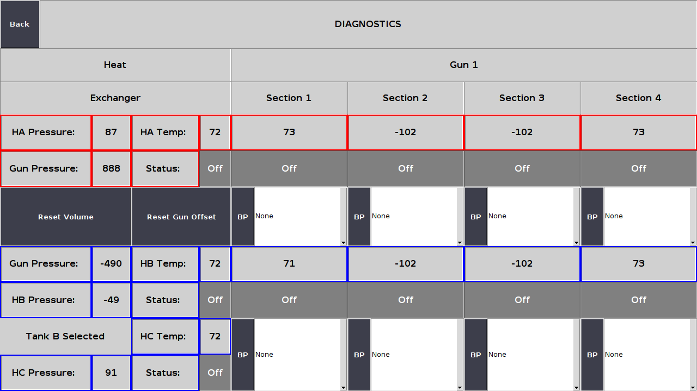
Figure 6
Manage Chemical Screen:
- Tank Levels
- Tank Temperatures
Figure 7
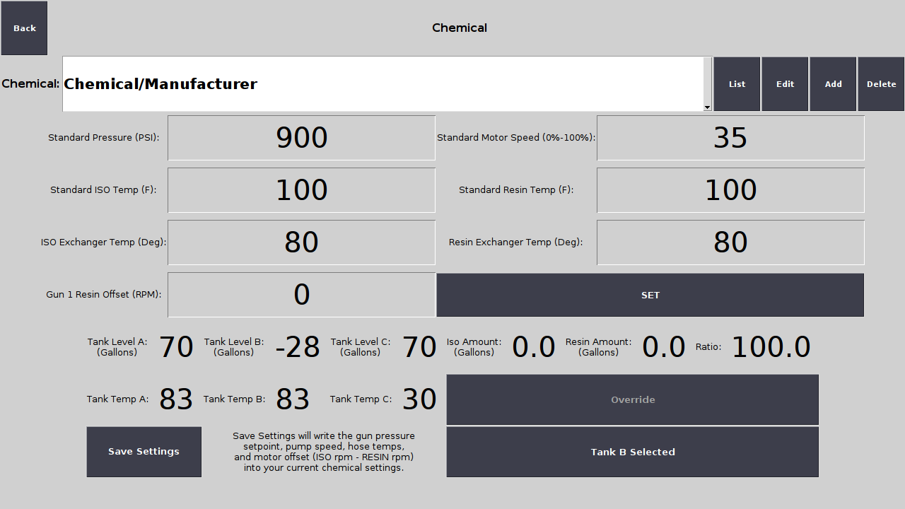
Figure 8

Transfer Pump Check
To start this process, turn all breakers off in the control box except the number 12 shown in Figure 1 and Figure 9.
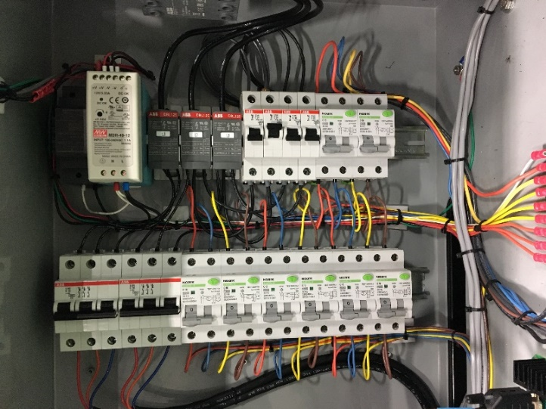
Figure 9
At this point, there is a distinction between a single and dual proportioners in a rig as well as the number of tanks that you have. The transfer pumps are to be controlled either by the proportioner itself or by a switch box located on the wall (depending on where your integrator/builder placed the box, see Figure 10). It is best to test one side at a time in order to diagnose problems should they arise. Also, complete the testing of both pumps on one proportioner then repeat the process on the other should you have 2 proportioners in your rig.
The first step is to set the Gun Pressure Setpoint below 600psi, this is to avoid an alarm that disables the proportioner. To test the Iso side, unplug the “Transfer Pump B” or “Tank B” connector depending on if you have a switch box or not. See Figure 10, it shows the switch box set up to test an Iso transfer pump.
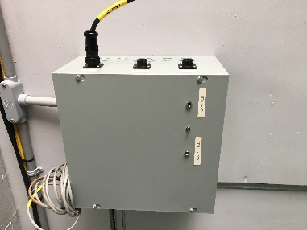
Figure 10
Before testing, double check all the valves are open between your tanks and proportioner. If one of the valves is closed, you could build pressure and cause a hose failure. Next, you will put the proportioner in “Run” mode. At this point, the transfer pump should be continuously spinning clockwise at the pump face. If this is the case, put the proportioner back in “Standby” mode. There is no need to run this test very long because pressure does not need to be built up yet. After the Iso transfer pump has been successfully tested, move on to the Resin transfer pump.
The same process applies, unplug the “Transfer Pump A” or “Tank A” connector depending on you have a switch box or not. Before testing, double check all the valves are open between your tanks and proportioner. Put the proportioner in “Run” mode and make sure the correct transfer pump is spinning clockwise at the pump face. If you have a third tank, the process is the same but make sure the switch on the switch box is indicating the correct tank.
When going to test Tank C transfer pump, be sure that the toggle switch on the switch box is oriented correctly. The next step is to go to the “Manage Chemical” screen. On this screen, in the bottom right corner you will see a toggle box labeled “Tank B Selected”; touch this button once and it will say “Tank C Selected”. At this point you can proceed with testing Tank C Transfer pump in the same manner as the other two. IF YOU HAVE TANKS A, B AND C, ALWAYS BE MINDFUL OF WHICH TANK YOU HAVE SELECTED/INDICATED BOTH ON THE PROPORTIONER AND ON THE SWITCH BOX.
***If you have stick pumps refer to operations manual for set up and testing

Fill Heaters
After transfer pumps have been cleared, the system now needs to be primed by filling the heaters. As mentioned in the previous section, the transfer pumps will kick on while in Run Mode and heater pressure is below 47psi. This process is best done by doing one side at a time, therefore disconnect the transfer pumps that aren’t being used by unplugging the connector from the side of the proportioner (If Single Proportioner, Single Resin Tank) or from the Switch Box (If Dual Proportioner, or Dual Resin Tanks). Then go into Run Mode (no need to press start) and let the pump fill the heater. More than likely, there will be air in the line leading up to the heater that you are trying to fill. Open the valve at the bottom of the heater and place a cup at the opening. Once chemical is flowing that means all the air has been pushed out of the way, you can then shut the valve. Monitor the heater pressure and observe that the transfer pump stops once pressure reaches 47psi. If pressure continues to climb and or/reaches 200 psi, begin troubleshooting this issue (could be bad sensor, crossed connection, or incorrect tank selection).
Repeat this process for the other side by plugging in the cable corresponding to the next transfer pump.

Fill the Lines
Filing the lines should also be done one side at a time and all hose heat and preheater breakers should be off. See Figure 1.
Turn off the breaker to the proportioner motor that isn’t being used (breaker 1 and 2). For example, if filling the Iso line, turn off the Resin Motor breaker (2).
- Set pressure setpoint to 300 psi
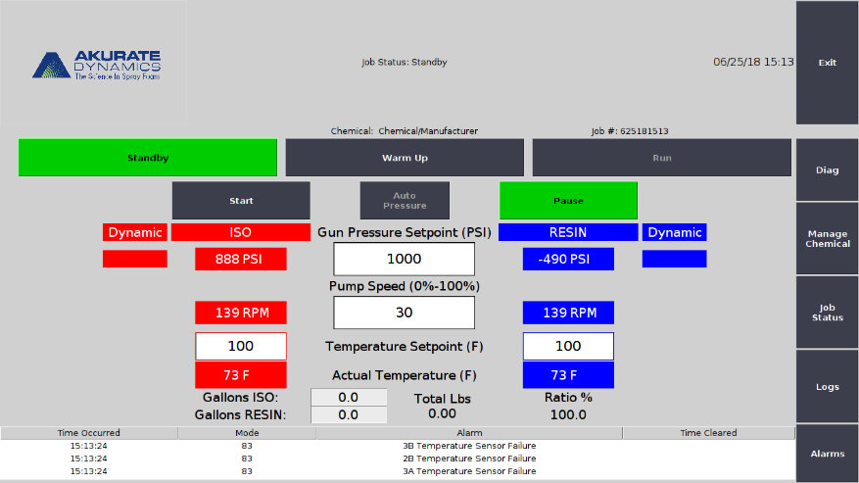
Figure 11
- Set Motor Speed to 20%
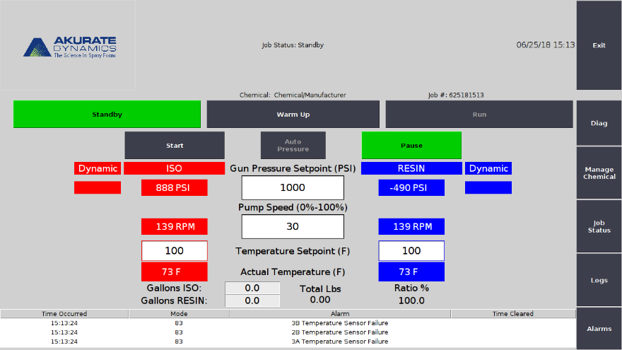
Figure 12
- Select Run Mode and press “Start”
- Let the proportioner run until you no longer see air coming out of the gun manifold.
- Once confident air is out of the hoses, go into Standby Mode and close the gun manifold.
Repeat this process for the next side.

Hose Diagnostics
Now that the lines are filled, the hose heat breakers (3-12) and preheater breakers (13-15) should all be flipped to the on positions. Input temperature settings on the Main Screen (as seen in Figure 13) and test the hose heat by going into warm-up or run mode and monitor that hoses heat properly.
Figure 13

Test Spray
Now that hoses have reached temperature and have passed the diagnostics testing, input operational settings and perform a test spray. Monitor for proper operation of the system.

