Final Diesel Heater Setup.

Press OK button until you see the Temperature with the large degrees C and turn it to the max value of 35
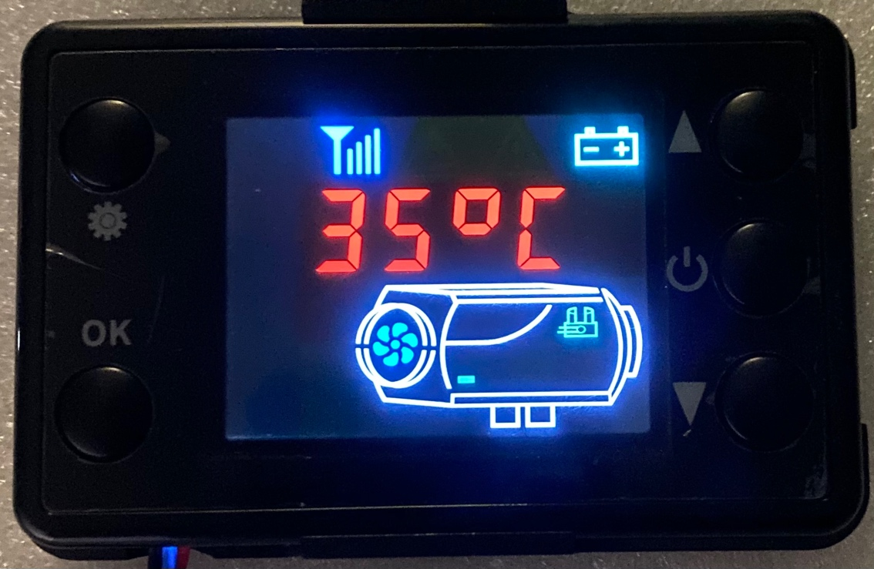

Press OK button to get to the error code screen and make sure there are no errors. The screen should look like this.
